6 Golden Rules To Write Clean Code

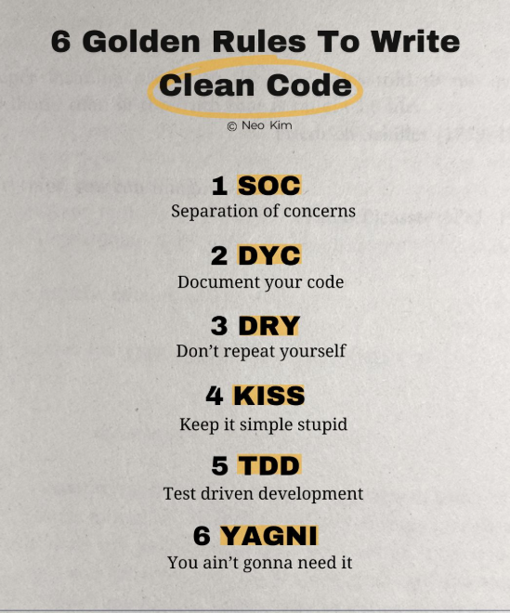

1️⃣ Separation of Concerns (SOC)
↳ Break down a complex program into smaller units.
↳ Each unit should focus on a specific task.
2️⃣ Document Your Code (DYC)
↳ Write code for your future self and others.
↳ Explain complex code sections with comments and documentation.
3️⃣ Don't Repeat Yourself (DRY)
↳ Don't waste time writing the same code again.
↳ Instead use functions, modules, and existing libraries.
4️⃣ Keep It Simple, Stupid (KISS)
↳ Simple is hard, but better.
↳ Readable code > clever code.
5️⃣ Test Driven Development (TDD)
↳ Write a failing test first.
↳ Write code to make the test pass.
↳ Then clean up the code without changing behaviour.
6️⃣ You Ain't Gonna Need It (YAGNI)
↳ Build only essential features.
↳ Don't build features you think you might need later.
The bottom line:
✓ Leave the codebase cleaner than you found it.

